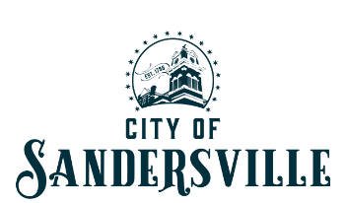

BIDS FOR THE CITY OF SANDERSVILLE

DESCRIPTION: Materials for Community Health Care Center

DEPARTMENT: Electric Department

BIDS: Transformers
- Gresco Utility | $17,895.00 **
- Southern Transformer Services | $18,000.00
- Sunbelt Solomon | $21,942.00

BIDS: Materials
- Gresco Utility | $14,354.25 **
- Anixter | $16,302.14
- Irby | $22,918.70

BIDS: Parking Lot Lights
- Gresco Utility | $11,455.00 **
- Anixter | $14,533.25

